**DLD LAB 03 – HOME TASKS**

**Task 04:**

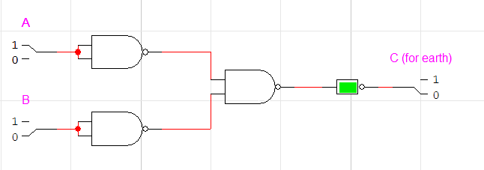

**Task 05:**

